1x2(2x2) PM Filter Coupler

1. Features

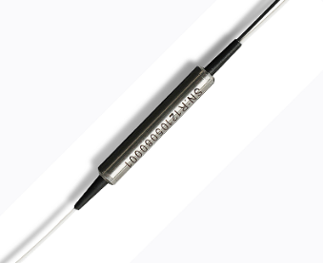
- Low Insertion Loss
- High Extinction Ratio
- High Isolation
- High Stability and Reliability

2. Applications
- EDFA
- Fiber Optical Instrument
- Power Monitoring
- Fiber Sensor

- Specifications
Parameters | Unit | Value
Operating Wavelength | nm | 1310
Operating Bandwidth | nm | ±30
Insertion Loss | dB | ≤3.6
Extinction Ratio | dB | ≥20
Return Loss | dB | ≥50
Directionality | dB | ≥50
Power | mW | 300
Operating Temperature | ℃ | -5~+65
Storage Temperature | ℃ | -40～+80
Port Type | / | 1x2
Fiber Type | / | PM 13-U25D
Fiber Length | m | 1.0±0.1m, others on request
Connector | / | FC/APC, others on request
Package Dimension | mm | Φ5.5x38 (900μm Loose Tube )

For device with connector, IL is 0.3dB higher, RL is 5dB lower, ER is 2dB lower.
The default connector key is aligned to slow axis.

4．Package Dimension
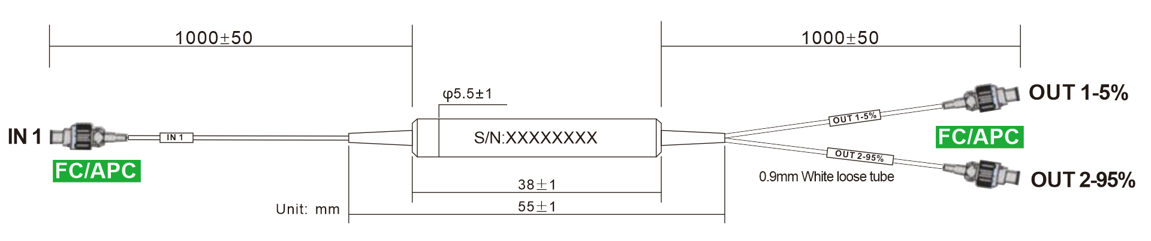
5. Ordering information
Couper | - | XXX | XXX | XX | XXX | XX | XX | - | X | X
 |  | Port NO | Wavelength | Splitting Ratio | Modules type | Fiber Type | Fiber Length |  | Com  connector | Port  Connector
PM Filter  Coupler  =PMFCP |  | 12=1X2 | 131=1310nm | 50=50/50 | ST1=Ф3.0X45 | 02=250um fiber | 10=1.0m |  | 0=None | 0=None
PM Filter  Coupler  =PMFCP |  | 22=2X2 | 148=1480nm | 90=90/10 | ST2=Ф3.0X54 | 09=0.9mm Tube | XX=Customized |  | 1=FC/UPC | 1=FC/UPC
PM Filter  Coupler  =PMFCP |  |  | 155=1550nm | 99=99/01 | SB=90 X20 X10 | 20=2.0mm Tube |  |  | 2=FC/APC | 2=FC/APC
 |  |  | 980=980nm | 95=95/5 | XX=Customized | 30=3.0mm Tube |  |  | 3=SC/UPC | 3=SC/UPC
 |  |  | 106=1064nm |  |  | XX=Customized |  |  | 4=SC/APC | 4=SC/APC
 |  |  | 780=780nm |  |  |  |  |  | 5=LC/UPC | 5=LC/UPC
 |  |  |  |  |  |  |  |  | 6=LC/APC | 6=LC/APC
 |  |  |  |  |  |  |  |  | X=Customized | X=Customized

Part Number | Product Description
PMFCP-1213195ST10910-22(S) | 1*2 PM Filter Coupler, Splitting Ratio 95/5, Steel Tube type, PM 13-U25D fiber With 0.9mm Hytrel White Tube, fiber Length 1m (with connector), connector FC/APC, connector key is aligned to slow axis, fast axis blocked.

